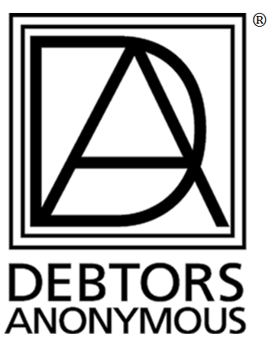

PLEASE SHARE THIS ANNOUNCEMENT AT YOUR MEETINGS
& FORWARD THIS E-MAIL TO OTHER D.A. MEMBERS.
The World Service Conference Public Information Committee (PI) presents the following Fellowship-Wide Conference call:

How Attractive! Chairperson of the Board, Michalene’s ESH on PI

Sunday, April 14, 2019
2:00-3:30 PM EST 1:00-2:30 PM CST
12:00-1:30 PM MST 11:00-12:30 AM PST

Dial-In Number: Toll:1 (605) 472-5540, Access Code: 617093#
International call info at www.debtorsanonymous.org/call-in-access

Speaker will share her Public Information experience doing PI outreach

Time will be given for Q&A and shares after the presentation

For recordings of Fellowship Wide calls: www.debtorsanonymous.org/podcasts

