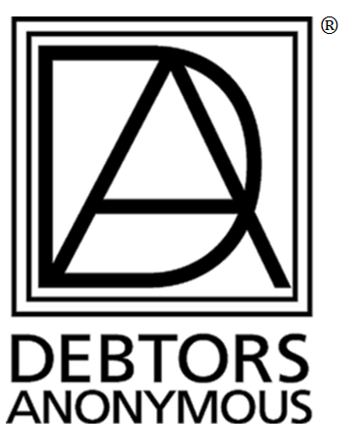
PLEASE SHARE THIS ANNOUNCEMENT AT YOUR MEETINGS
& FORWARD THIS E-MAIL TO OTHER D.A. MEMBERS.
The World Service Conference Public Information Committee (PI) presents the following Fellowship-Wide Conference call:

I Am the Face of DA
Sunday, June 30, 2019
2:00-3:30 PM Eastern 1:00-2:30 PM Central
12:00-1:30 PM Mountain 11:00AM-12:30 PM Pacific

Dial-In Number: Toll:1 (605) 472-5540, Access Code: 617093#
International call info at www.debtorsanonymous.org/call-in-access.

Individuals share their successes during public outreach

Ellen NY “How to Feel Comfortable Talking DA to an Organization”
Elita CA “Reaching Out to Underserved and Under-Represented”
Maia CA “Public Service Radio Announcements (PSAs)”
Tom R. MD and Maia CA “DA Embarking on New Opportunities in Social Media”
Susan WA “DA Mention in AARP Magazine Column”
Tom R. “Creation of DA Welcome Videos”

For 30 minutes after the speaker presentations, callers will be given the opportunity to participate in shares and Q & A.

For recordings of Fellowship Wide calls:www.debtorsanonymous.org/podcasts

